 | 7.2.3 Editors - 3D Viewport - Tool Shelf - Mesh - Sculpt Mode
Table of content
Tool Shelf - Mesh - Sculpt Mode 4
Transform and Annotate tools 4
Brush cursor 4
Brushes settings 4
Hotkeys 5
Symmetry 5
Draw 5
Draw Sharp 5
Clay 5
Clay Strips 5
Clay Thumb 5
Layer 6
Inflate 6
Blob 6
Crease 6
Smooth 6
Flatten 6
Fill 6
Scrape 6
Multiplane Scrape 6
Pinch 6
Grab 7
Elastic Deform 7
Snake Hook 7
Thumb 7
Pose 7
Nudge 7
Rotate 7
Slide Relax 7
Boundary 7
Cloth 8
Simplify 8
Mask 8
Draw Face Sets 8
Multires Displacement Eraser 8
Multires Displacement Smear 9
Paint 9
Smear 9
Mask selection tools group 9
Box Mask, Lasso Mask and Line Mask 9
Active Tool setting 9
Front Faces only 9
Limit to Segment 9
Box Hide 9
Box / Lasso Faceset tools group 10
Box Face Sets 10
Tool Settings 10
Front faces only 10
Lasso Face Sets 10
Tool Settings 10
Front faces only 10
Box Trim / Lasso Trim tools group 10
Box Trim 10
Tool Settings 10
Trim Mode 11
Extrude Mode 11
Use Cursor Depth 11
Lasso Trim 11
Tool Settings 11
Trim Mode 11
Shape Orientation 11
Extrude Mode 11
Use Cursor Depth 11
Line Project 11
Tool Settings 11
Mesh Filter 12
Usage 12
Tool Settings 12
Filter Type 12
Smooth 12
Scale 12
Inflate 12
Sphere 12
Random 12
Relax 12
Relax Face Sets 12
Surface Smooth 13
Shape preservation 13
Per Vertex Displacement 13
Sharpen 13
Smooth Ratio 13
Intensity Details 13
Curvature Smooth Iterations 13
Strength 13
Deform Axis 13
Cloth Filter 13
Tool Settings 13
Filter Type 14
Strength 14
Force Axis 14
Orientation 14
Cloth Mass 14
Cloth Damping 14
Use Face Sets 14
Use Collisions 14
Color Filter 14
Tool Settings 14
Filter Type 14
Strength 14
Edit Face Sets 15
Tool Settings 15
Mode 15
Modify Hidden 15
Mask by Color 15
Tool Settings 15
Threshold 15
Contiguous 15
Invert 15
Preserve Previous Mask 15

Tool Shelf - Mesh - Sculpt Mode
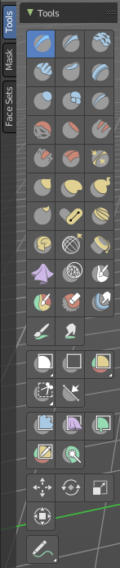
In Sculpt mode with a mesh object you will find mainly brushes in the tool shelf.

Transform and Annotate tools
The transform and annotate tools at the end of the list are explained in the chapter 7.1.1 Editors - 3D View - Tool Shelf - Object Mode. We won't cover this tools again here.

Brush cursor
When you activate one of the brushes then the mouse cursor turns into a brush cursor. This cursor represents the size of the current brush. It aligns to the surface under the mouse. When you start to draw then the brush cursor will disappear except for one little yellow dot in the center.
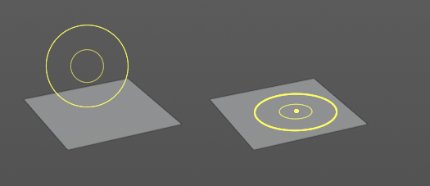
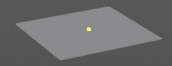

Brushes settings

The different brushes settings can be found in the sidebar in the tools tab. Or in the properties editor in the Active Tool and Workspace settings tab. Or above the header area.

The different brushes settings in the Active Tool and Workspace settings are explained in the chapter 25.1 Editors - Properties Editor - Tools Tab.

We won't cover this chapters again, but just explain what the different brushes does.

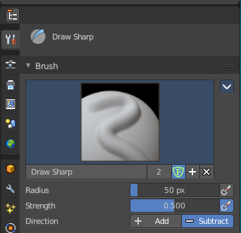
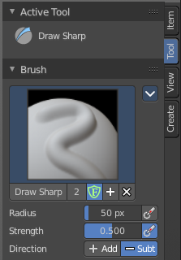
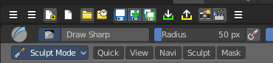

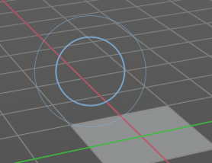
Hotkeys
Pressing X allows you to change the brush size onscreen. Drag the mouse to increase or decrease the size. Left click applies the new size, right click cancels the resizing.

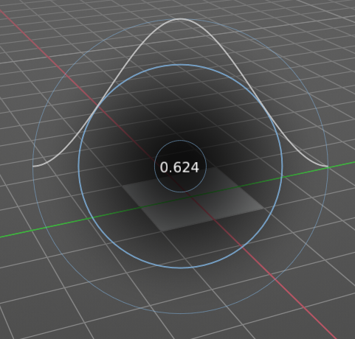
Pressing C allows you to change the strength of the brush. Drag the mouse to increase or decrease the size. Left click applies the new size, right click cancels the resizing.

Symmetry
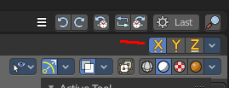
Note that the sculpting mode starts with Symmetry in X axis on. You can turn this off up right in the header.

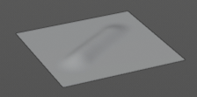
Draw
Draws a stroke.

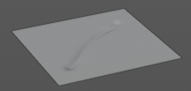
Draw Sharp
Draws a negative stroke. In the Brush panel you will see that the direction is set to subtract instead of add. But you can also set it to add. This brush is a bit sharper than the Draw brush.

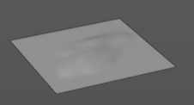
Clay
Draws a stroke. The pencil reacts different than with draw. It's more like sculpting, not so much like drawing, and deforms the surface also more in a sculpting style. The brush has a pretty weak effect in its default settings.

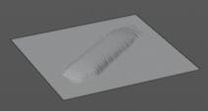
Clay Strips
Draws little strips on top of each other.

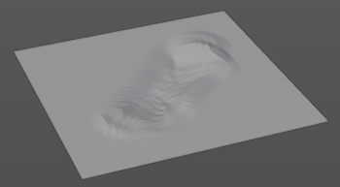
Clay Thumb
Draws like you would use the thumb.

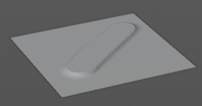
Layer
Adds a layer stroke with a predefined height. This height can be adjusted with the height slider in the Brushes panel.

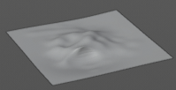
Inflate
Inflates or deflates existing strokes. See Inflate/Deflate setting in the Brush panel.

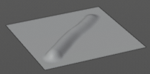
Blob
Reacts pretty similar to Draw. It draws a stroke.

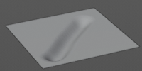
Crease
Draws a negative stroke.

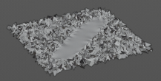
Smooth
Smoothens the surface.

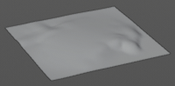
Flatten
Flattens the surface.

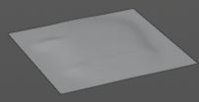
Fill
Tries to fill the valley between two hill strokes. Hard to see in the shot. And the default values have a very weak influence.

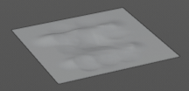
Scrape
As the name says. With this brush you can scrape.

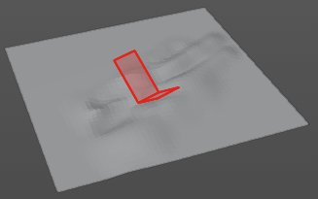
Multiplane Scrape
As the name says. With this brush you can scrape. But this brush takes different surface angles into account.

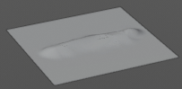
Pinch
Pinches existing strokes. Hard to see in the shot. What happens is that the stroke at the top becomes much sharper.

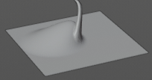
Grab
Allows you to grab a portion of the sculpt mesh and drag it around.

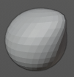
Elastic Deform
Allows you to grab a portion of the sculpt mesh and drag it around. This brush tries to preserve the volume of closed meshes. So it's best used at a closed geometry.

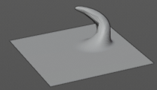
Snake Hook
Allows you to grab a portion of the sculpt mesh and drag it around. The tool reacts a bit different than the Grab tool.

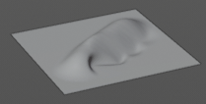
Thumb
Allows you to pull geometry around than you would press your thumb into the claw.

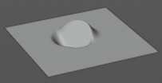
Pose
Allows you to pose the geometry under the brush by rotating it freely.

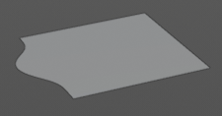
Nudge
Nudges the geometry. Drag it sidewards.

Rotate
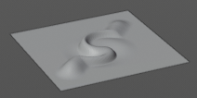
Rotates the geometry under the brush, aligned with the brush alignment.

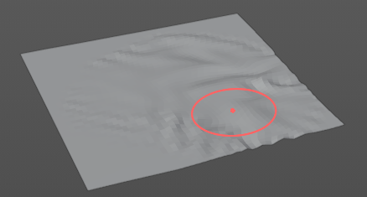
Slide Relax
Allows you to relax the surface in drag direction by dragging with the mouse over it.

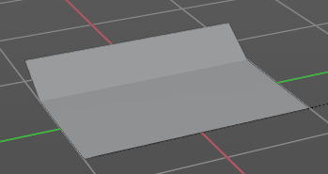
Boundary
Allows to deform the boundary geometry in various modes.

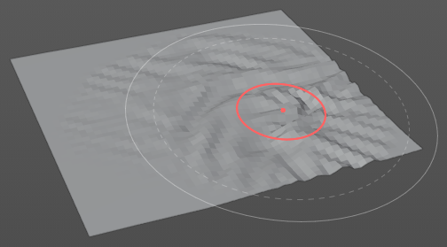
Cloth
The cloth brush allows you to crumple the surface like it would be a piece of cloth.

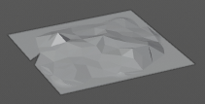
Simplify
Has no effect on quad geometry. This tool is of interest for Dyntopo sculpting. It simplifies the geometry, using the less dense areas as reference.

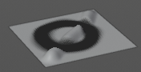
Mask
Allows you to mask out specific parts of the mesh by painting it black. Black means no sculpt stroke possible in this area.
In the Brush panel you can negate the effect. And remove the mask by repainting over it with Direction set to Subtract.
The mask menu in the header provides you with further functionality like clear and invert the mask.

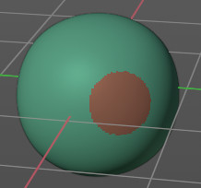
Draw Face Sets
Allows you to draw so called faces set areas. It is some kind of a permanent mask. Every drawn face set gets a random color assigned. This face sets can then be manipulated with the Mesh Filter tool. Or you can use them to hide the parts away that you don't want to sculpt at the moment.
Holding Shift will relax or smooth the edges of the Face Sets.
Holding Ctrl will continue drawing the same Face Set as the one under the cursor.
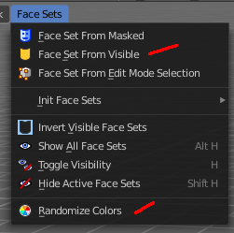
Once you have painted Face Sets, the Face Set beneath your mouse pointer can be hidden by pressing the H hotkey.
Hotkey Shift H hides all Face Sets but the one under your mouse pointer. See also the Face Sets menu.
To reset all face sets choose Face Sets from Visible in the Face Sets menu, followed by Randomize Color. This should clear all colors.

Multires Displacement Eraser
Deletes the displacement information of the Multires Modifier. And resets the mesh to the subdivision limit surface.
Use case is to delete parts of the sculpt or to fix reprojection artifacts after applying a Shrinkwrap Modifier.

Multires Displacement Smear
Moves Multires displacement over the surface. This works like smearing a displacement texture. The brush can be used continually without creating topology artifacts.

Paint
Paint over vertex colors. Note that this feature is not supported when you work in Dynatopo.

Smear
Smears painted vertex colors. Note that this feature is not supported when you work in Dynatopo.

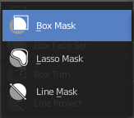
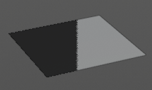
Mask selection tools group

Box Mask, Lasso Mask and Line Mask
Allows you to mask out specific parts of the mesh by selecting mesh parts, and mask them with black. Black means no sculpt stroke possible in this area.
This tools is, different from the mask brush not brushes, but select tools. Box mask and Lasso mask behaves like the general box and lasso select methods. To subtract hold down ctrl. Line mask selects along a line.
The mask menu in the header provides you with further functionality like clear and invert the mask.

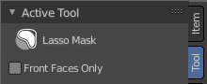
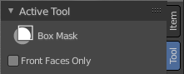
Active Tool setting

Front Faces only
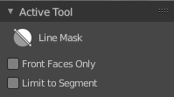
Affect only the faces that points to the front.

Limit to Segment
Line mask only. Affect only the current segment.

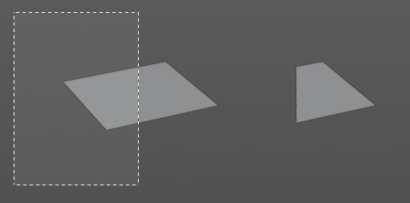
Box Hide
This tool allows you to box select parts of the mesh that gets hidden then. To reveal hidden mesh parts left click anywhere.

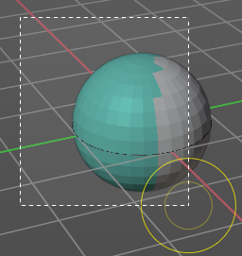
Box / Lasso Faceset tools group
Allows to select faces and apply a face set to it.

Box Face Sets
Box select an area of the mesh to apply a face set.

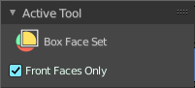
Tool Settings

Front faces only
Only affect the front faces.

Lasso Face Sets
Lasso select an area of the mesh to apply a face set.

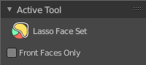
Tool Settings

Front faces only
Only affect the front faces.

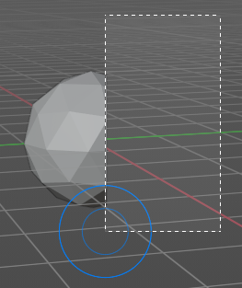
Box Trim / Lasso Trim tools group
Trim the geometry with a rectangle or lasso.

Box Trim

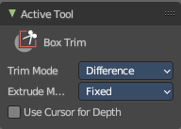
Tool Settings

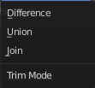
Trim Mode
What trim method to choose. Trim uses a boolean method. You have the choice between difference, union and join.

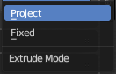
Extrude Mode
How to deal with extrude.

Use Cursor Depth
Use cursor location and radius for the dimensions and position of the trimming shape.

Lasso Trim

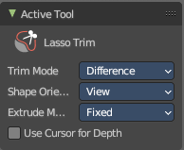
Tool Settings

Trim Mode
What trim method to choose. Trim uses a boolean method. You have the choice between difference, union and join.

Shape Orientation
Use the view or the surface of the object to orientate the trimming shape.

Extrude Mode
How to deal with extrude.

Use Cursor Depth
Use cursor location and radius for the dimensions and position of the trimming shape.

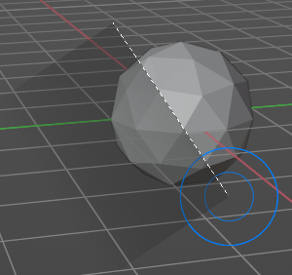
Line Project
Cuts away part of the mesh along a line.

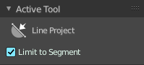
Tool Settings
Apply the action only to the current segment.

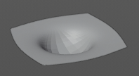
Mesh Filter
Apply a Mesh Filter Type. Mesh filters are something like deform modifiers.

Usage
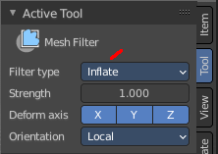
Choose the filter type that you want to apply in the Tool Settings panel. Then drag with the mouse to adjust the amount.
To work with Face Sets first tick Use Face Sets in the Active Tool panel. Then hover the mouse over the Face Set that you want to manipulate. Then drag with the mouse to adjust the amount.
You have to adjust everything beforehand. This tool has no last operator.

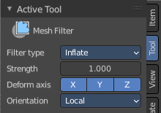
Tool Settings

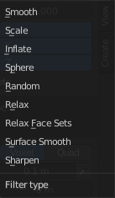
Filter Type

Smooth
Smoothens the surface.

Scale
Scales the surface.

Inflate
Inflates the surface.

Sphere
Forms the surface to a sphere.

Random
Randomizes the vertices positions.

Relax
Relaxes the mesh.

Relax Face Sets
Smooth the edges of all face sets.

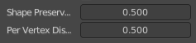
Surface Smooth
Smooth the surface of the mesh, preserving the volume.

Shape preservation
How much of the original mesh is preserved when smoothing.

Per Vertex Displacement
How much the position of each individual vertex influences the final result.

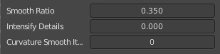
Sharpen
Sharpen the cavities of the mesh.

Smooth Ratio
How much smoothing is applied to polished surface.

Intensity Details
How much creases and valleys are intensified.

Curvature Smooth Iterations
How smooth the resulting shape is. This feature ignores high frequency details.

Strength
The strength of the effect.

Deform Axis
Limit the effect to single world axis.

Cloth Filter
Applies a cloth filter type.
Choose the filter type that you want to apply in the Tool Settings panel. Then drag with the mouse to adjust the amount.
You have to adjust everything beforehand. This tool has no last operator.

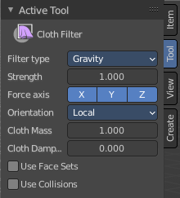
Tool Settings

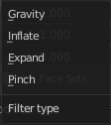
Filter Type
The cloth filter type.

Strength
The filter strength.

Force Axis
Apply the force in the selected axis.

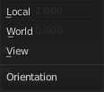
Orientation
Orientation of the axis to limit the filter force. Local, World or View.

Cloth Mass
Mass of each simulation particle

Cloth Damping
How much the applied forces are propagated through the cloth.

Use Face Sets
Use an existing face set under the mouse for the cloth filter brush.

Use Collisions
Collide with other collider objects in the scene.

Color Filter
Applies a filter to modify the current sculpt vertex colors.

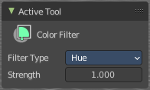
Tool Settings

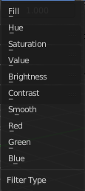
Filter Type
What kind of filter to apply to the vertex colors.

Strength
The strength of the filter.

Edit Face Sets
Allows you to grow or shrink the face set under the mouse.

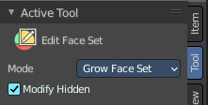
Tool Settings

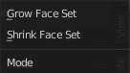
Mode
Grow or shrink.

Modify Hidden
Affect hidden face sets too.

Mask by Color
Creates a mask from the sculpt vertex colors under the mouse.

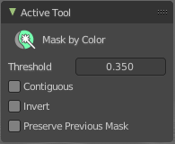
Tool Settings

Threshold
How much changes in color affect the mask generation. Or in other words, the threshold after which the color gets count as an equal color to the current vertex color under the mouse to mask this color out.

Contiguous
Only mask out color parts that are connected.

Invert
Invert the generated mask.

Preserve Previous Mask
Add to or subtract from the current color mask.

